
Water Level Detection System Using Arduino and LabVIEW for Flood Monitoring

Name | Registration No. | Batch | Roll No. | Signature
Harikishanthini K | 220906286 | A1 | 6 | 
Shruthi Ramprasad | 220906308 | A1 | 8 | 
Ishani Dey | 220906486 | A1 | 23 | 

1. Abstract
Floods pose a significant threat to both life and infrastructure. Continuous water level monitoring is essential for early flood detection and prevention. This project presents a cost-effective and real-time water level detection system using an Arduino UNO microcontroller integrated with LabVIEW for monitoring and visualization. The system utilizes ultrasonic sensors to measure water levels and display data via a user-friendly GUI on LabVIEW. This setup not only enhances decision-making in emergency scenarios but also supports smart flood monitoring using virtual instrumentation.

2. Introduction
India, being prone to seasonal floods, faces extensive damage annually. There is a dire need for accurate water level monitoring in real-time. Conventional methods often lack responsiveness or cost-efficiency. The proposed system leverages Arduino UNO, ultrasonic sensors, and LabVIEW to build a Virtual Instrumentation-based solution for remote and efficient flood-level monitoring.
This project is inspired by existing research on virtual instrumentation systems for water level measurement and aims to implement a working prototype with real-time data display and alert mechanisms.

3. Objectives
- To design a real-time water level monitoring system using Arduino.
- To integrate the system with LabVIEW for graphical visualization and alert systems.
- To provide a cost-effective and scalable solution for flood-prone regions.
- To create a user-friendly interface for monitoring and data analysis.

4. System Components
- Arduino UNO
- Ultrasonic Sensor (HC-SR04)
- Breadboard and jumper wires
- LED indicators
- USB cable for interfacing
- PC with LabVIEW software

5. Methodology
a. Hardware Setup:
- The ultrasonic sensor is placed vertically above the water level.
- The sensor continuously measures the distance from the sensor to the water surface.
- The Arduino calculates the water level based on the predefined tank or river height.
- Threshold values are programmed for warning and danger levels.
b. Software Integration (LabVIEW):
- Serial communication between Arduino and LabVIEW is established.
- LabVIEW reads real-time data via VISA.
- Graphical representation (bar graph/gauge) displays the water level.
- Visual and sound alerts (buzzer, LED) trigger on threshold breaches.
6. Block Diagram
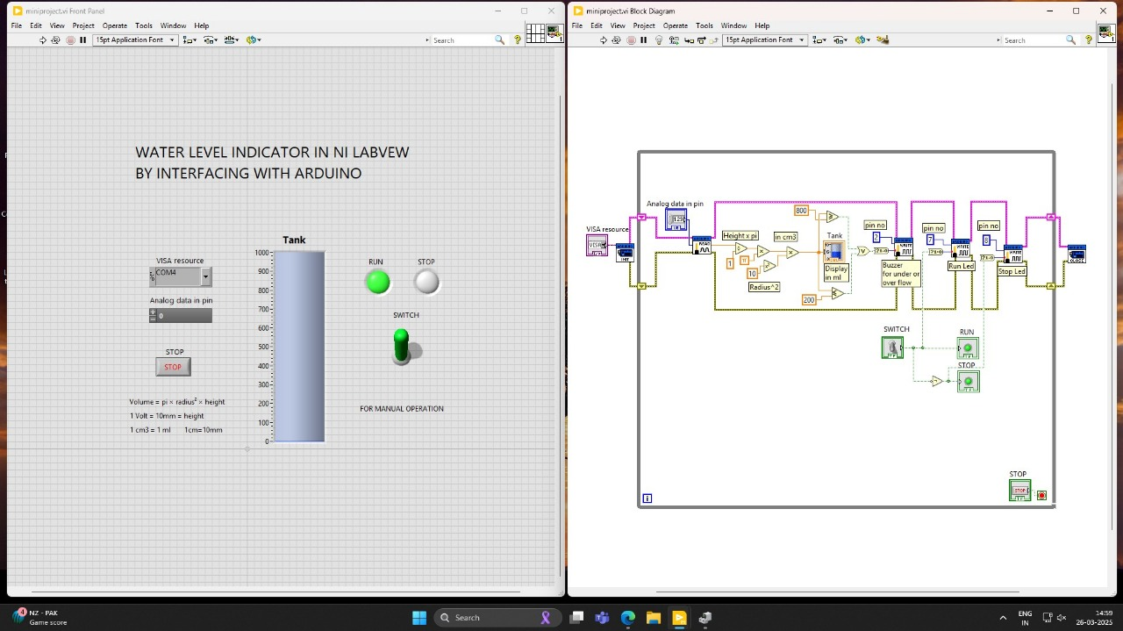
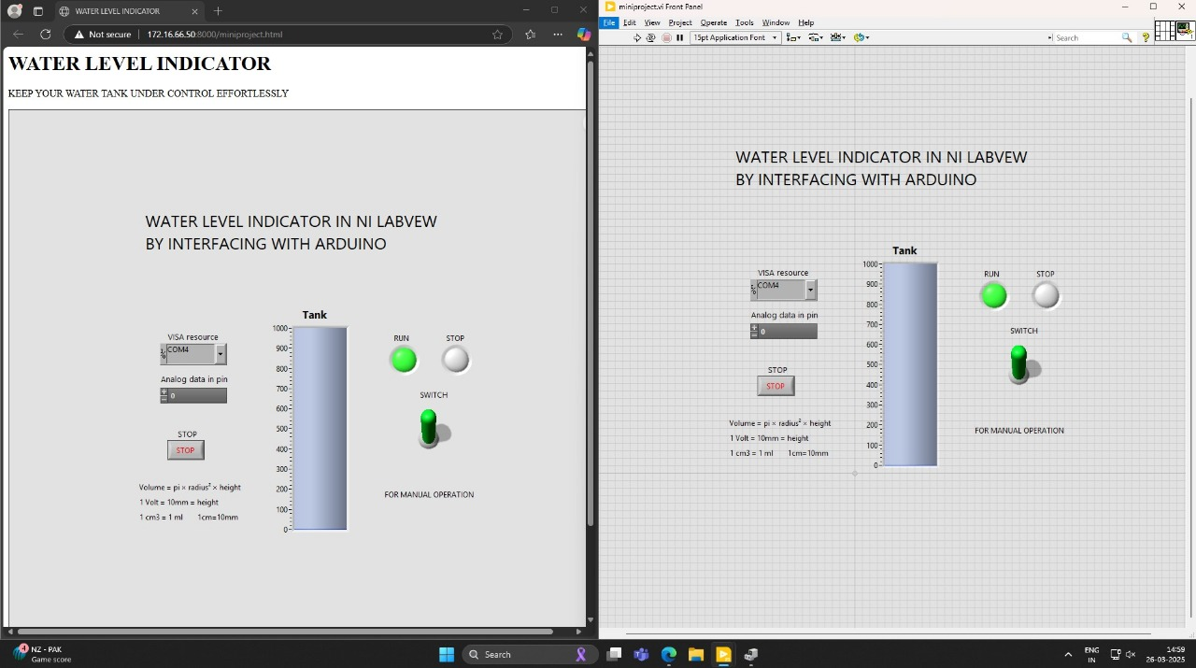

7. Flowchart

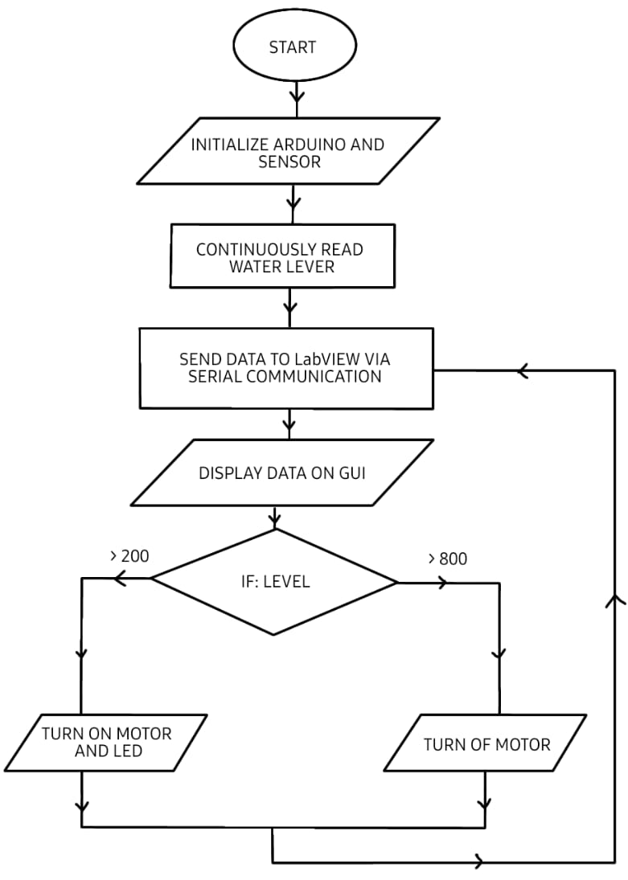
8. Results and Discussion
- The system accurately detects water levels using the ultrasonic sensor.
- Real-time data is efficiently displayed and monitored using LabVIEW.
- Alerts are timely and help simulate emergency conditions.
- This project demonstrates the potential of low-cost IoT + VI integration for environmental monitoring.

9. Conclusion
This project presents a reliable, scalable, and cost-effective water level monitoring system. The integration of Arduino and LabVIEW creates a robust tool for real-time flood monitoring. The approach proves effective in simulation and can be extended to multi-sensor systems in real-world applications.

10. Future Scope
- Integration with IoT modules (e.g., ESP8266) for remote monitoring via the internet.
- Cloud-based data storage and analytics.
- SMS/Email alerts for authorities.
- Solar-powered operation for deployment in remote areas.

11. Individual Contributions
- Harikishanthini: - Simulation
- Ishani Dey: - Report
- Shruthi Ramprasad: - Literature Review
12. References
- Manoharan, M., et al., “Water Level Detection System Based on Arduino and LabVIEW for Flood Monitors Using Virtual Instrumentation.” International Journal of Pure and Applied Mathematics, 2018.
- Article from JETIR Journal on smart flood monitoring using VI and embedded systems.

